# ASSIGNMENT

**Submitted**

**By**

**[Sahil Mushtaq]**

**[2023A7R004]**

**Semester – 1st**

**Department: CSE - Cyber Security**



# Model Institute of Engineering &Technology (Autonomous)

(Permanently Affiliated to the University of Jammu, Accredited by NAAC with “A” Grade)Jammu, India

2023

**1. Write the program for finding duplicate elements in array**.

#include<stdio.h>

#include<conio.h>

void main()

{

int arr[20],i,j, size;

printf("Enter the number of elements: ");

scanf("%d", &size);

printf("Enter those elements: ");

for(i=0;i<size;i++)

{

scanf("%d",&arr[i]);

}

printf("Duplicate elements are these: \n");

for(i=0; i<size; i++)

{

for(j=i+1;j<size;j++)

{

if(arr[i]==arr[j])

{

printf("%d\n",arr[i]);

}

}

}

getch();

}

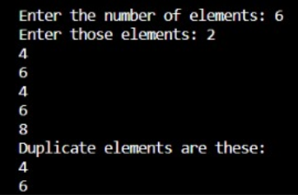

**2. Write the program for finding largest of three numbers in all methods.**

**(using ternary, elseif, nested if)**

USING TERNARY METHOD:-

#include <stdio.h>

void main()

{

int num1, num2, num3;

// Input three numbers

printf("Enter three numbers: ");

scanf("%d %d %d", &num1, &num2, &num3);

// Find the largest using ternary operator

int largest = (num1 > num2) ? ((num1 > num3) ? num1 : num3) : ((num2 > num3) ? num2 : num3);

// Print the result

printf("The largest number is: %d\n", largest);

}

USING ELSE-IF:-

#include<stdio.h>

void main()

{

int num1,num2,num3;

// Input three numbers

printf("Enter three numbers: ");

scanf("%d %d %d", &num1, &num2, &num3);

// Find the largest using else-if statements

if (num1 >= num2 && num1 >= num3) {

printf("The largest number is: %d\n", num1);

} else if (num2 >= num1 && num2 >= num3) {

printf("The largest number is: %d\n", num2);

} else {

printf("The largest number is: %d\n", num3);

}

}

USING NESTED IF:-

#include<stdio.h>

void main()

{

int num1,num2,num3;

// Input three numbers

printf("Enter three numbers: ");

scanf("%d %d %d", &num1, &num2, &num3);

//Find the largest using nested if statements

if (num1 >= num2)

{

if (num1 >= num3)

{

printf("The largest number is: %d\n", num1);

}

else

{

printf("The largest number is: %d\n", num3);

}

}

else

{

if (num2 >= num3)

{

printf("The largest number is: %d\n", num2);

}

else

{

printf("The largest number is: %d\n", num3);

}

}

}

